EXPERIMENT 2 — STEP-WISE SOLUTION

PART A: EXTRACT
Step 1: Import the Global Superstore Dataset
We opened Microsoft Power BI Desktop and selected Home → Get Data → Excel Workbook. We selected Global Superstore Dataset.xlsx and clicked Transform Data to open the dataset in Power Query Editor.

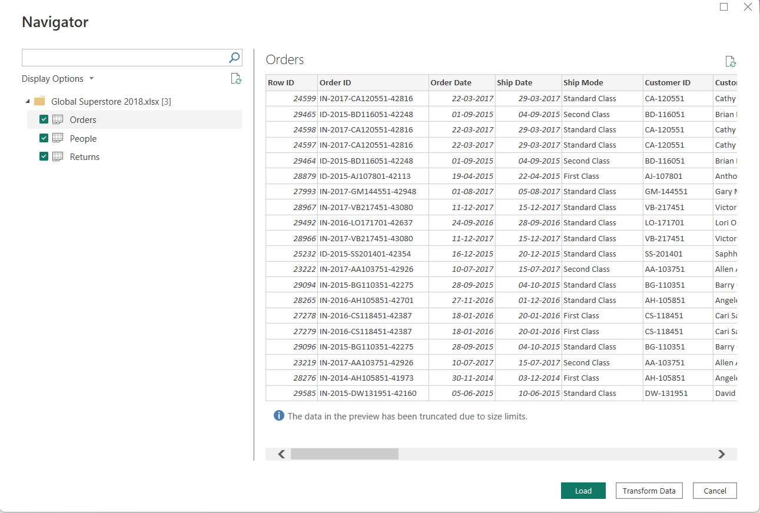

Step 2: Select and Verify the Required Tables
From the Navigator, we selected the Orders, Returns, and People worksheets. After importing them, we checked the Queries pane to make sure all three tables were available.
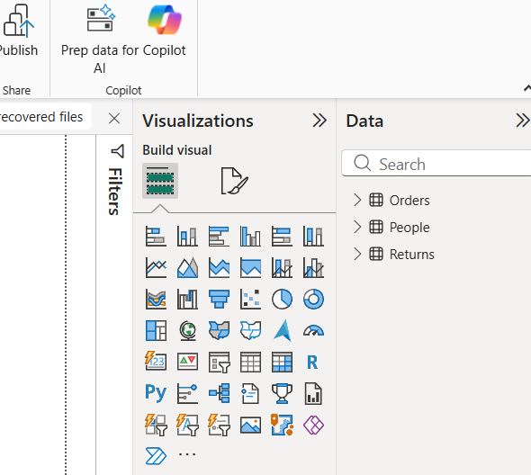

PART B: TRANSFORM

Step 3: Clean and Transform the Orders Table
We selected the Orders table and performed the required cleaning operations. Duplicate records and blank rows were removed, data types were checked, and column names were corrected where necessary. We also extracted Year and Month from Order Date, created the Profit Margin column, and standardized Region and Segment values.
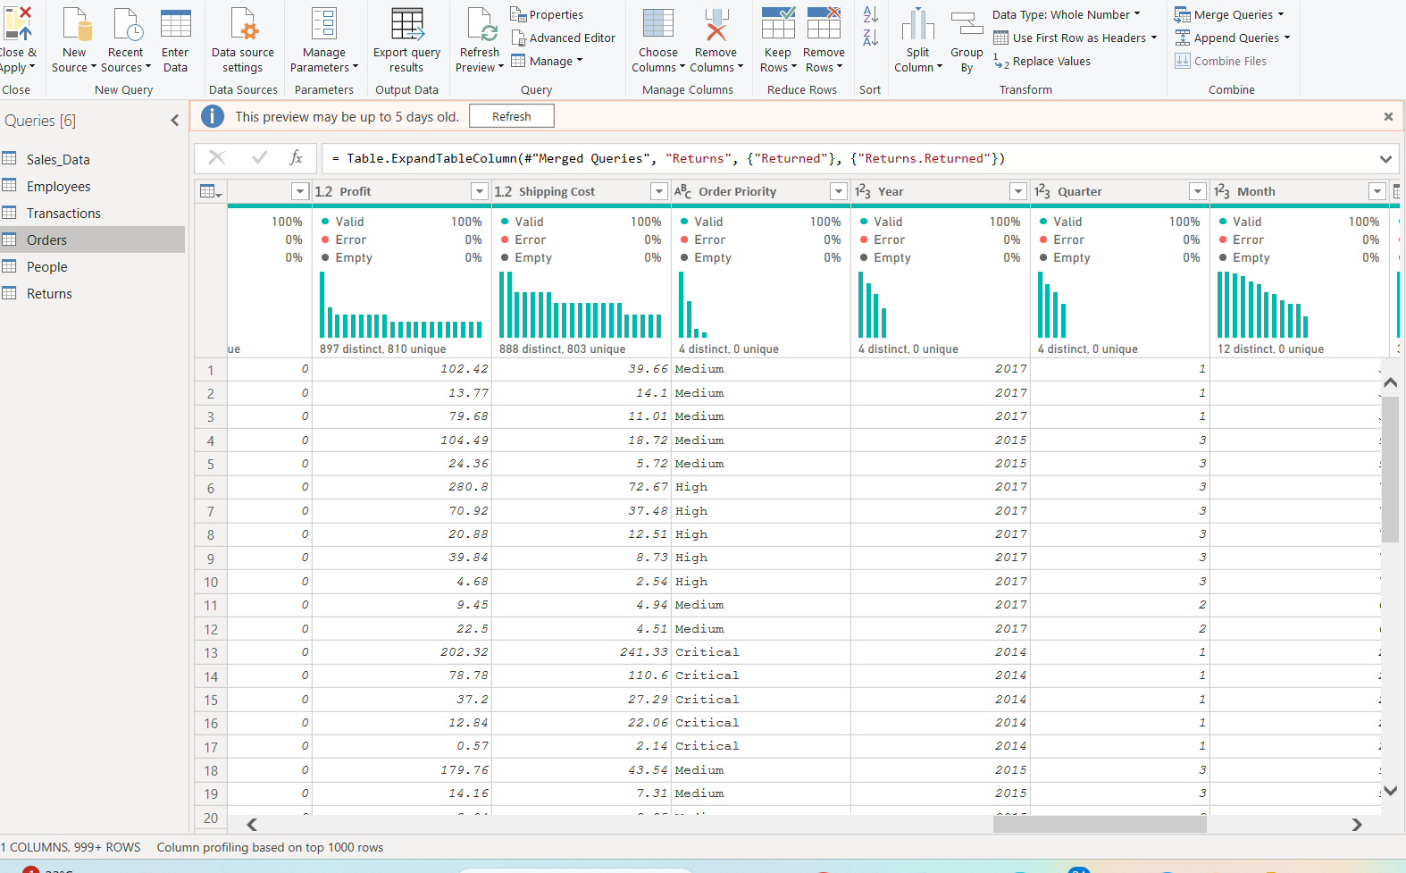

Step 4: Clean the Returns and People Tables
We transformed the Returns table by removing duplicate Order IDs, checking missing values, and standardizing the Returned field. The People table was also checked for regional consistency, and unnecessary columns were removed.
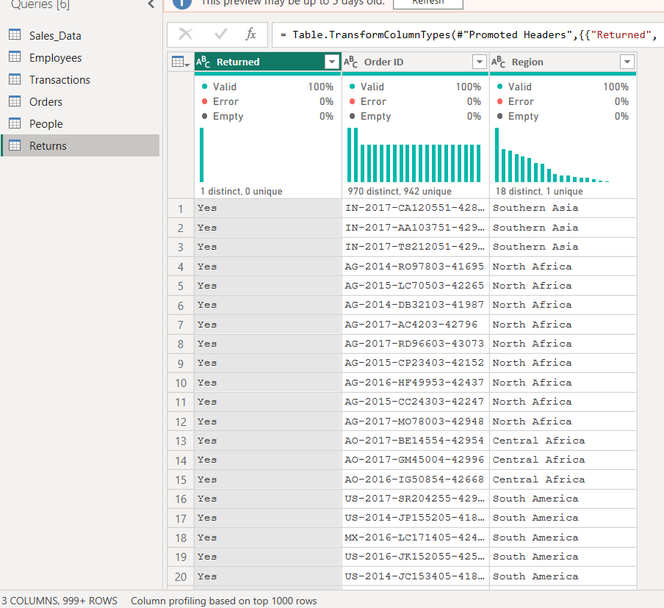
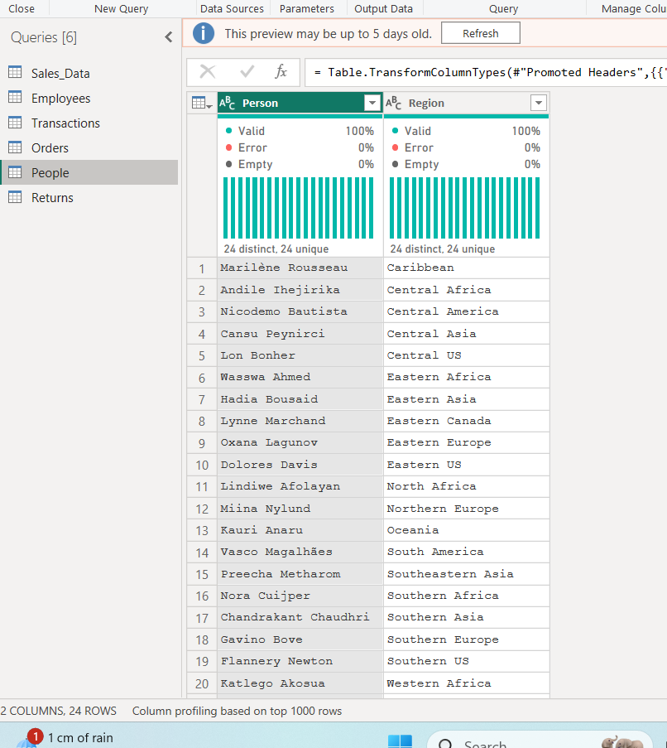

Step 5: Merge the Required Tables
We merged the Orders and Returns tables using Order ID as the common field. After merging, we reviewed the Applied Steps to verify that all transformations were correctly recorded and then selected Close & Apply to load the transformed data into Power BI.
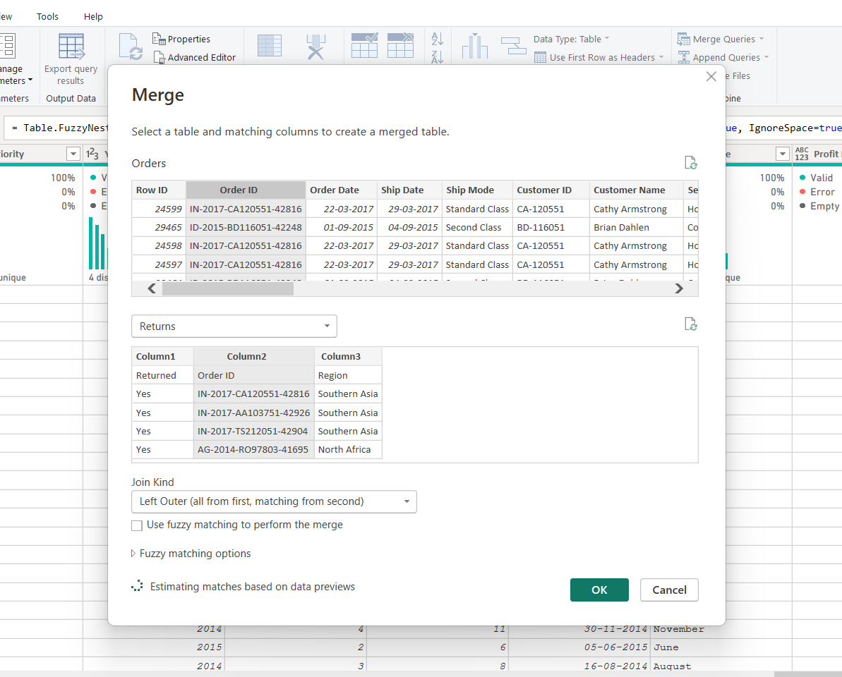
PART C: LOAD
Step 6: Create the Data Model and Relationships
After loading the transformed data, we opened Model View and created relationships between the tables. The Orders and Returns tables were related using Order ID, while Orders and People were related using Region.

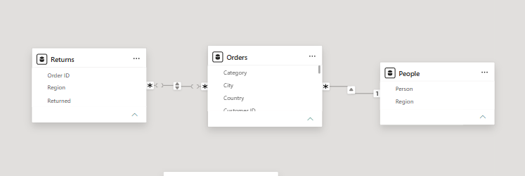

Step 7: Create DAX Measures and Report
We created DAX measures for Total Sales, Total Profit, Profit Margin, and Total Orders. Finally, we used these measures and fields from the related tables to create a simple report visual for business analysis.

